Selenium 727721EUCS095

NITHISH KUMAR P

Day-5

Task:01

Js code package com.selenium.nithish.demo; import org.openqa.selenium.By; import org.openqa.selenium.WebDriver; import org.openqa.selenium.WebElement; import org.openqa.selenium.edge.EdgeDriver; import org.openqa.selenium.interactions.Actions; import io.github.bonigarcia.wdm.WebDriverManager; public class D5C1 {

public static void main(String[] args) throws InterruptedException {

WebDriverManager.edgedriver().setup(); WebDriver driver=new EdgeDriver(); driver.get("https://demoqa.com/droppable/");

Actions a=new Actions(driver);

WebElement source_ele=driver.findElement(By.id("draggable")); WebElement dest_ele=driver.findElement(By.id("droppable")); a.clickAndHold(source_ele).release(dest_ele).build().perform();

}

}

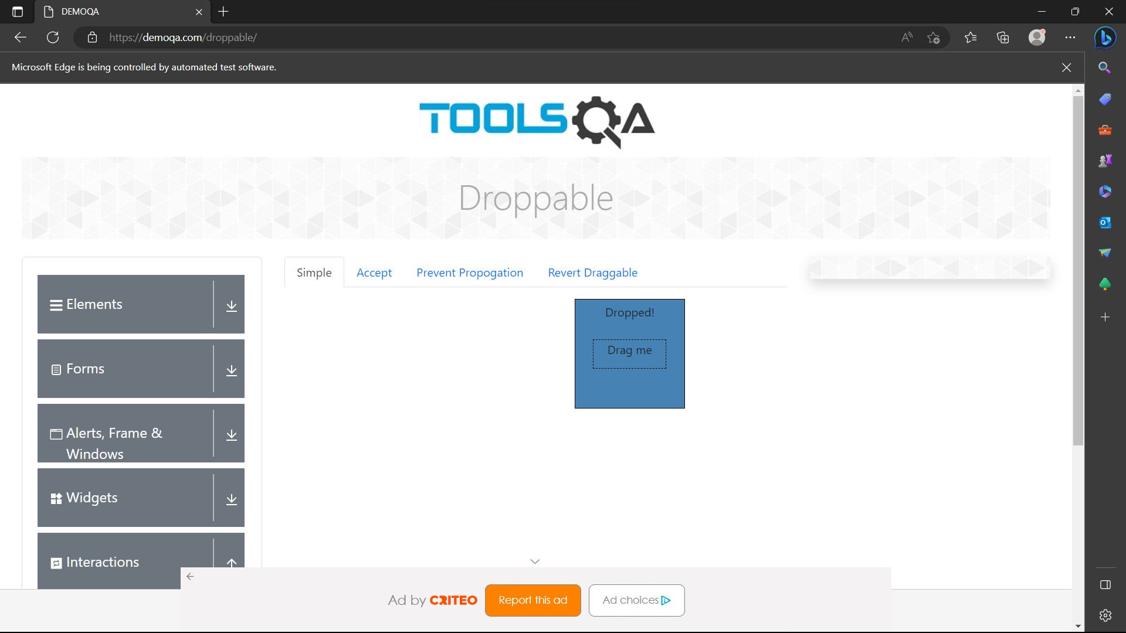

Task:02

Js code package com.selenium.nithish.demo; import org.openqa.selenium.By; import org.openqa.selenium.WebDriver; import org.openqa.selenium.WebElement; import org.openqa.selenium.chrome.ChromeDriver; import org.openqa.selenium.chrome.ChromeOptions; import org.openqa.selenium.interactions.Actions; import io.github.bonigarcia.wdm.WebDriverManager; public class D5T2 {

public static void main(String[] args) {

WebDriverManager.edgedriver().setup(); WebDriver driver=new EdgeDriver(); driver.get("https://demoqa.com/droppable/");

Actions a=new Actions(driver);

WebElement source_ele=driver.findElement(By.id("draggable")); WebElement dest_ele=driver.findElement(By.id("droppable")); a.clickAndHold(source_ele).release(dest_ele).build().perform();

a.dragAndDrop(source_ele, dest_ele).build().perform(); }

}



Task:03

Js code package com.selenium.nithish.demo; import org.openqa.selenium.Alert; import org.openqa.selenium.By; import org.openqa.selenium.WebDriver; import org.openqa.selenium.WebElement; import org.openqa.selenium.edge.EdgeDriver; import io.github.bonigarcia.wdm.WebDriverManager; public class D5C3 {

public static void main(String[] args) throws Exception {

WebDriverManager.edgedriver().setup(); WebDriver driver=new EdgeDriver();

driver.get("https://demo.guru99.com/test/delete_customer.php"); WebElement txt_box= driver.findElement(By.name("cusid")); WebElement submit_btn=driver.findElement(By.name("submit")); txt_box.sendKeys("401"); submit_btn.click();

Alert alert1=driver.switchTo().alert(); alert1.dismiss(); txt_box.clear(); txt_box.sendKeys("402"); submit_btn.click();

Alert alert2=driver.switchTo().alert(); alert2.accept();

Alert alert3=driver.switchTo().alert(); String txt=alert3.getText(); alert3.accept();

System.out.println(txt);

}

}

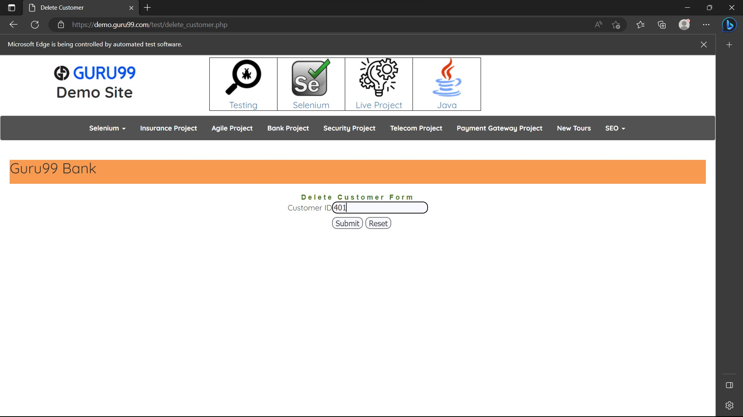

Task:04

Js code package com.selenium.nithish.demo; import org.openqa.selenium.By; import org.openqa.selenium.JavascriptExecutor; import org.openqa.selenium.WebDriver; import org.openqa.selenium.WebElement; import org.openqa.selenium.edge.EdgeDriver; import io.github.bonigarcia.wdm.WebDriverManager; public class D5C4 {

public static void main(String[] args) {

WebDriverManager.edgedriver().setup(); WebDriver driver=new EdgeDriver();

driver.get("https://www.abhibus.com/bus-ticket-booking"); WebElement src=driver.findElement(By.id("source")); src.sendKeys("Coimbatore");

WebElement dst=driver.findElement(By.id("destination")); dst.sendKeys("Chennai");

WebElement

datepick=driver.findElement(By.xpath("//*[@id=\"datepicker1\"]"));

JavascriptExecutor js=(JavascriptExecutor) driver; js.executeScript("arguments[0].setAttribute('value',

'04/10/2023')",datepick); }

}

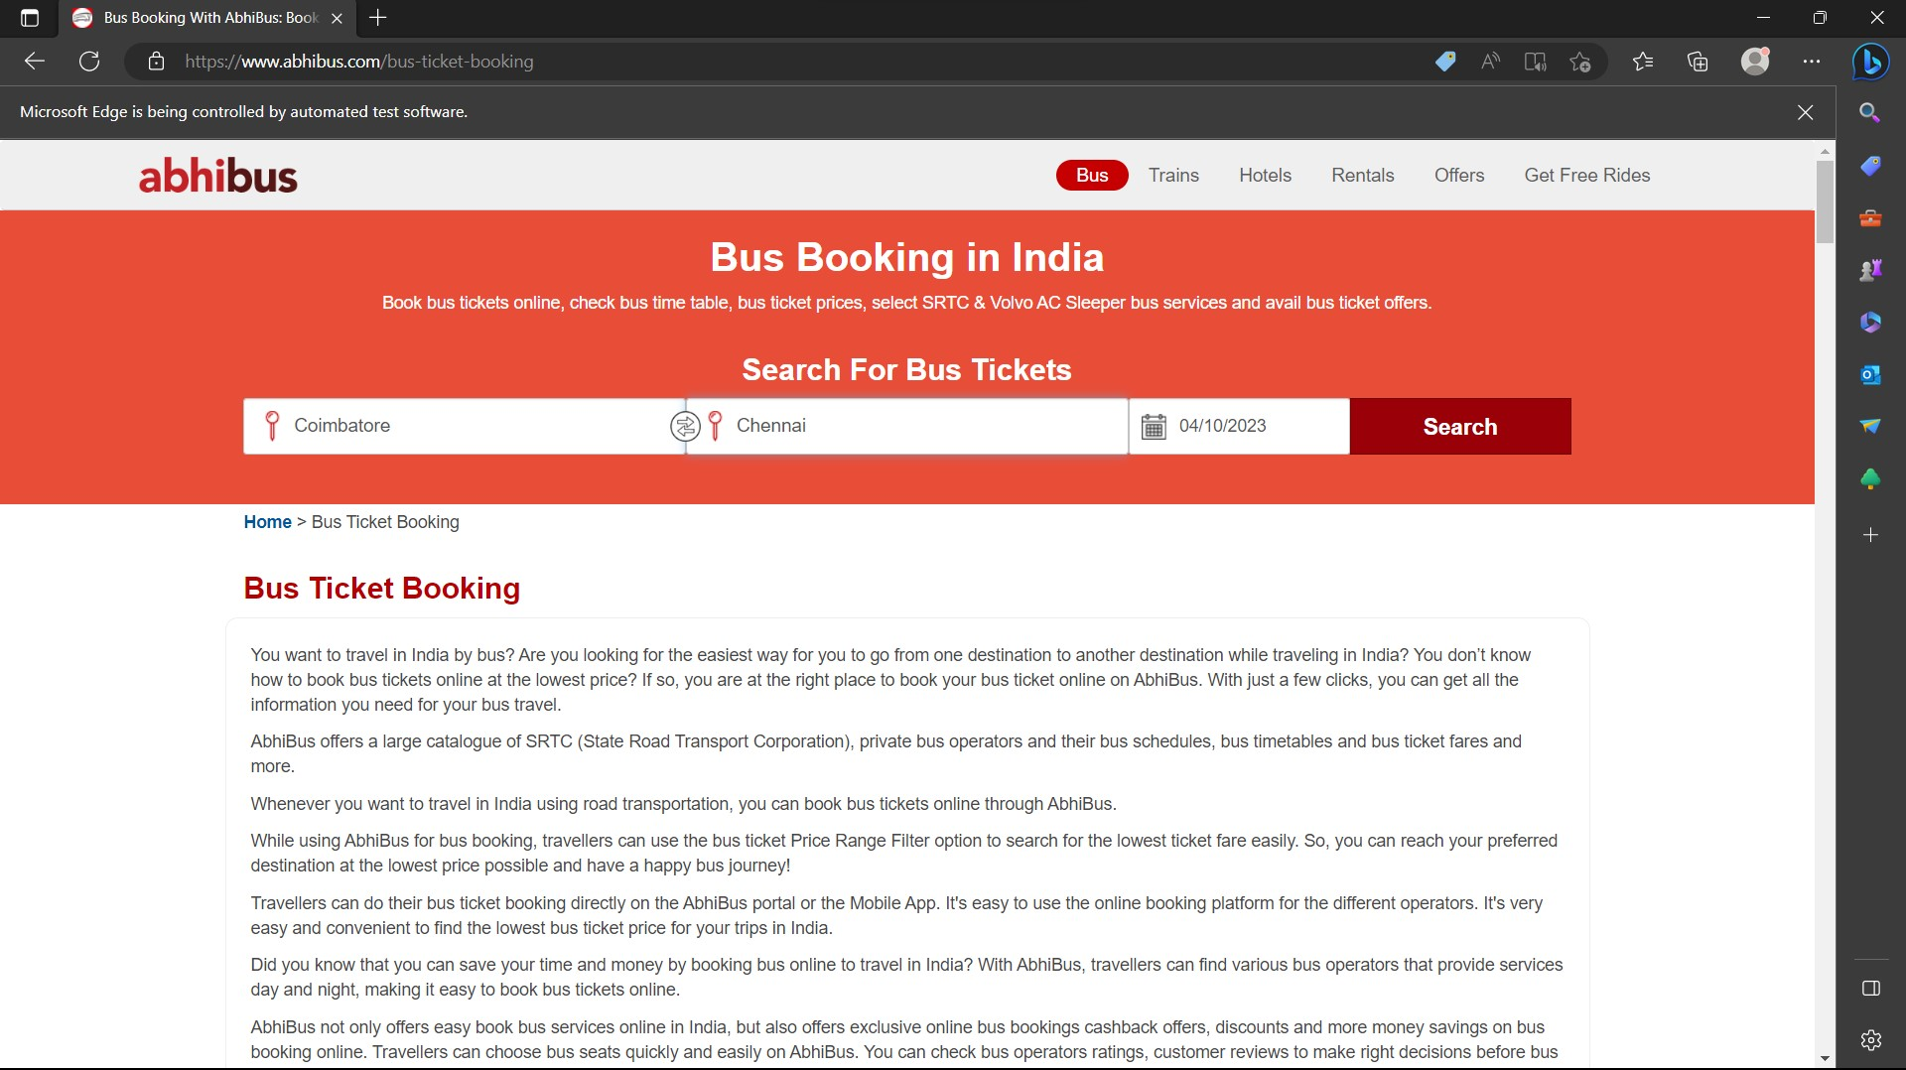

Task:05

Js code package com.selenium.nithish.demo; import java.util.Set; import org.openqa.selenium.By; import org.openqa.selenium.Keys; import org.openqa.selenium.WebDriver; import org.openqa.selenium.WindowType; import org.openqa.selenium.chrome.ChromeDriver; import org.openqa.selenium.chrome.ChromeOptions; import io.github.bonigarcia.wdm.WebDriverManager; public class D5C5 {

public static void main(String[] args) throws Exception { WebDriverManager.chromedriver().setup(); ChromeOptions co=new ChromeOptions(); co.addArguments("--remote-allow-origins=*"); WebDriver driver=new ChromeDriver(co); driver.get("https://google.com"); driver.findElement(By.name("q")).sendKeys("Apple"); driver.findElement(By.name("q")).sendKeys(Keys.ENTER);

Thread.sleep(3000);

String t1=driver.getTitle();

String i1=driver.getWindowHandle();

System.out.println(t1); System.out.println(i1); driver.switchTo().newWindow(WindowType.TAB); driver.get("https://google.com"); driver.findElement(By.name("q")).sendKeys("Selenium"); driver.findElement(By.name("q")).sendKeys(Keys.ENTER);

Thread.sleep(3000);

String t2=driver.getTitle();

String i2=driver.getWindowHandle();

System.out.println(t2); System.out.println(i2); driver.switchTo().newWindow(WindowType.TAB); driver.get("https://google.com"); driver.findElement(By.name("q")).sendKeys("Cucumber"); driver.findElement(By.name("q")).sendKeys(Keys.ENTER);

Thread.sleep(3000);

String t3=driver.getTitle();

String i3=driver.getWindowHandle();

System.out.println(t3);

System.out.println(i3);

Set<String>s=driver.getWindowHandles();

System.out.println("Number of Tabs opened: "+s.size()); }

}

